Operational Concept Document: Source Code Repository Architecture

Matthew Synborski | matthewsynborski@gmail.com
CSE-681 Project 5 - Fall 2013 – For Dr. Jim Fawcett
1 Executive Summary 4
2 Introduction 4
3 Top Level Architecture 5
3.1 Client 6
3.2 Repository Server 7
3.3 Structure 7
4 Plugin-based Architecture 8
4.1 Plugin Based Virtual Server 8
4.2 Plugin Based Client 8
5 Detailed Architecture: Client 9
5.1 Client: Collaborator 12
6 Detailed Architecture: Repository Server 20
6.1 Repository Server: Comm Package 21
6.2 Repository Server: RepoQueryServer Package 23
6.3 Repository Server: PackageDeleteServer/Client Package 28
6.4 Repository Server: NavGetServer Package 31
6.5 Repository Server: PackageGetServer Package 33
6.6 Repository Server: PackageCheckinServer Package 35
6.7 Repository Server: MetadataUpdateServer Package 37
6.8 Client: Package 2 40
7 Users 42
7.1 Content Providers 42
7.2 Customers 43
7.3 Program Managers 43
7.4 Administrators 43
8 Activities 44
8.1 User Activities (inputs) 44
8.2 Communications 50
9 Composition 51
9.1 Partitions 52
10 Organizing Principles 54
10.1 Views 54
11 Critical Issues 55
11.1 Feasibility 55
11.2 Security 55
11.3 Code Maintainability – Repository State 55
11.4 Simultaneous File Insertion 55
12 Conclusion 56

Executive Summary
Critical Concept Issues and Architectural Aspects
Large software, research and development, media and news companies all employ large groups of people working on large numbers of files. A tool that can provide a simple view of this content and relationships thereof, would allow these organizations to get their work done more efficiently. These large organizations need a tool that offers the ability to efficiently navigate and search through existing content, and associated metadata.
The Vault Client and Vault Server are a two content repository software tools that provide these capabilities. The Vault Client and Vault Server provide functionality that satisfy the project 4 requirements, and are designed for maximum reuse of code modules between the two software instances, as well as with previously developed text analysis and metadata generation tools.
The Vault Client and Vault Server handle the issue of simultaneous file insertion by aggregating incoming messages in a single message queue. This allows multiple clients to connect to a single Vault Server without impacting the user experience of that of the Vault Client.
Users external to a group that employs the Vault Server and Vault Client, such as Customers or other companies collaborating on a large project may want to access released files, but should be restricted from the full content of the Vault Server. The Vault Server and Vault Client address this problem by making use of user types. External parties can be assigned the “Customer” user type, which prevents unreleased files from being displayed by the Vault Client.
The software architecture of Vault Client and Vault Server share as much code as possible. File and message transfer code is common between both pieces of software.
- Uses WCF for communication between Vault Client and Vault Server
- Uses WPF for Vault Client
- Uses TextAnalyzer for queries
- Uses MetadataGen for metadata construction
For more details regarding the architecture, see the Composition section of this document.

Introduction
What are Vault Client and Vault Server?
Vault Client and Vault Server are two pieces of software that allow remote storage files and associated properties (referred to, from now on as “metadata”). They provide the ability to view the files and to edit the properties. Additionally, Vault Client and Vault Server provide a view of relationships between files. These relationships are specified by the user when the files are inserted. Relationships are presented to the user in terms of parents and children of a given file. The Vault Client and Vault Server support queries of text content in the files themselves, as well as queries of the files’ metadata. Queries can be text only, metadata only, or text and metadata together.

Top Level Architecture
The Repository Server and Client are portions of the Software Development Collaboration System shown below in the architecture diagram in Figure 1. This Operational Concept Diagram will cover the Client and Repository Server. It will not cover the Project Server or Test Harness Server, but will take their design concepts into account in order to provide a full discussion and coverage of the Client and Repository Server.
Figure 1: Software Development Collaboration System Context Diagram

Client
The client is the view and control of the entire federation of servers in the collaborative software development system. At the highest level, its uses are partitioned into two sections, shown below in Figure 2. The first section is server view and control. The second is cross-client collaboration.
Figure 2: Client Usage Partitions
Regarding the first section, the client offers the ability to control and perform oversight of the development project, check in, check out, analyze and view reports on source code packages, and specify post-test configurations, run tests and view test reports.
Regarding the second section, the client offers the ability to exchange documents, chat with other users via the client interface, and perform whiteboard collaboration.
{TODO: Cross reference partition sections of the client}

Repository Server
The Repository Server is the container for all work packages within the Source Code Repository, shown below in Figure 3. It contains all of the stored data that is requested by the Project Server. Via a client interface, it provides facilities for checking files in, checking out, generating reports, and performing and reporting analyses. The Repository Server also provides code to the Test Harness Server, and accepts and stores the test results.
The Repository Server is one of many servers that are composed from a general server architecture. This architecture is further described below in the Virtual Server section.
Figure 3: Repository Server Usage Partitions

Structure
The Repository Server is composed of the Server side set of plugins (.dll files), which are loaded at runtime. Each server-side plugin contains communications and tactical implementation for separate functions of the Repository Server. The plugin based architecture allows new features to be added to the Repository Server without affecting the overall architecture. It also allows new server types to be developed with minimal rework at the design-level.
On the Client side, the graphical user interface is composed of client-side plugins corresponding to the functions of the Repository Server. For each major feature/function of the Repository Server/Client, a pair of .dll files exists. Each pair of these .dll files is referred to as a plugin.

Plugin-based Architecture

Plugin Based Virtual Server
Because the needs of a development team are constantly changing as a program, project, or company evolve over time, it is desirable to provide a changing toolset. The assets associated with program management, software development, and verification and validation are different in terms of content. They are not different in terms of the general actions needed between the storage facility and the user. In all cases, the facility must:
- Assert access control policy: Control who can log in and what they can read and write
- Allow users to insert content as appropriate (store)
- Allow users to get information about content (query)
- Allow users to change the state of content (command)
The Repository Server is one of a myriad possible server partitions that can conform, architecturally to the above. In terms of its specific requirements
- Access control: The Repository server will assert access control. It will only allow users associated with permitted groups (developers, managers, testers) to read software content. It will only allow users associated with the testers group to write test results. It will only allow the user listed as the responsible individual to check in a file.
- Store: The Repository Server will allow software assets to be stored on its file system. For each software content asset (code file, documentation file, analysis file), a metadata file will be generated and stored alongside the content asset.
- Query: The Repository Server will support queries on the data (software assets and associated metadata).
- Command: The Repository Server will support a file deletion command, available only to users associated with the admin group.
The IServer generalized server architecture features a plug-in based design. Each Server that implements this architecture contains any number of IStoreServer, ICommandServer or IQueryServer plug-ins.

Plugin Based Client
The IClient generalized client architecture features a plug-in based design, similar to the IServer architecture. The Client contains a number of IStoreClient, ICommandClient or IQueryClient plugins. The client provides a WPF-based graphical user interface via each client-side plug-in. The client plugins display the views to the user, and for each plug in, perform the appropriate message forming, and passes resulting (XML) messages to the corresponding server plugins on the appropriate server via the Comm package. Message routing is handled by the client, as each client plug-in implements its own WCF-based communicator via the Comm package.
The generalized architecture of a virtual server is shown below in Figure 4.
Figure 4: Generalized Server Architecture UML Package Diagram

Detailed Architecture: Client
The Repository Client is a subset of the plug-in based Client’s full functionality. The plug-in based client will consist of plug-ins for the Test Client, Project Client and Repository Client.
The following section is concerned with only the portions of the client that pertain to the Repository Client and Server functionality.
The specific architecture for the Repository Client is shown below in Figure 5.
Figure 5: Respository Server UML Package Diagram
The following package diagram composes the Client
- Collaboration View
  - Whiteboard
  - Chat
  - File sharing
After collaboration over files in whiteboard view, the owner of the file will post to the repository server the resulting file. The file will be a timed file.
Chat and whiteboard view will be via multicast.
File sharing will be a post action of a new file to the repository server, and return a link to the repository server’s timed file. A post will come with the option of making the file a permanent file. Additionally, the file sharing will allow sharing of an existing repository file.
An appdomain will be used to create a local instance of the repo server on the client’s machine.
- Repository View
  - Vault Client partitions for Repository Server
  - Project Server View
    - View
Go from the list of items that the repository server is supposed to store to a list of server modules.
Draw the package diagram of the Repo server with comms, authentication, etc.
Repo server will store:
CheckinServer – Handles files being checked in. Via IStore interface.
CheckoutServer – Handles files being checked out. Via ICommand interface.
ReporterServer – Handles reports associated with packages. Will get a metadata category of test results. Will be dependent on a particular package. Used by test server, via IStore interface.
AnalysisServer – Handles analysis of content. Via IQuery interface.
QueryServer – Handles metadata queries. Via IQuery interface.

Client: Collaborator

Concept
The collaborator package provides all client to client collaborative functionality. The collaborator is a WPF-based pane within the Client graphical user interface (GUI) that contains separate sections for collaborative work. The collaborator is entirely separate from the communications (WCF-based message passing) used within the client-server plug-ins. Clients join a multicast-based “conversation” and have access to all content posted by any other user. Conversations will be divided by port number, so that multiple conversations and group members can be kept separate. Further, secure conversations can be encrypted, with their encryption keys stored within the repository server using its existing user access policy.

Uses
- Whiteboard collaboration – The collaborator presents a combined view of a 2-dimensional drawing. Each user posts graphical features, and the resulting drawing is rendered by each Client’s collaborator.
- Chat - A standard chat interface is provided. Upon entering a “conversation”, the user’s username is displayed in a list of participants. Messages are displayed at the bottom of the pane as the user types. When a user sends a message, the message is time stamped and displayed at the bottom of the message transcript history.
- Document share – The collaborator provides an informal file share. Files are available to all participants in a given conversation until the last user exits from the conversation. Additionally, an interface is provided for taking informal files (those files produced during a conversation) and checking them in to any of the servers.
The collaborator view is shown in a mockup diagram, below in Figure 6.
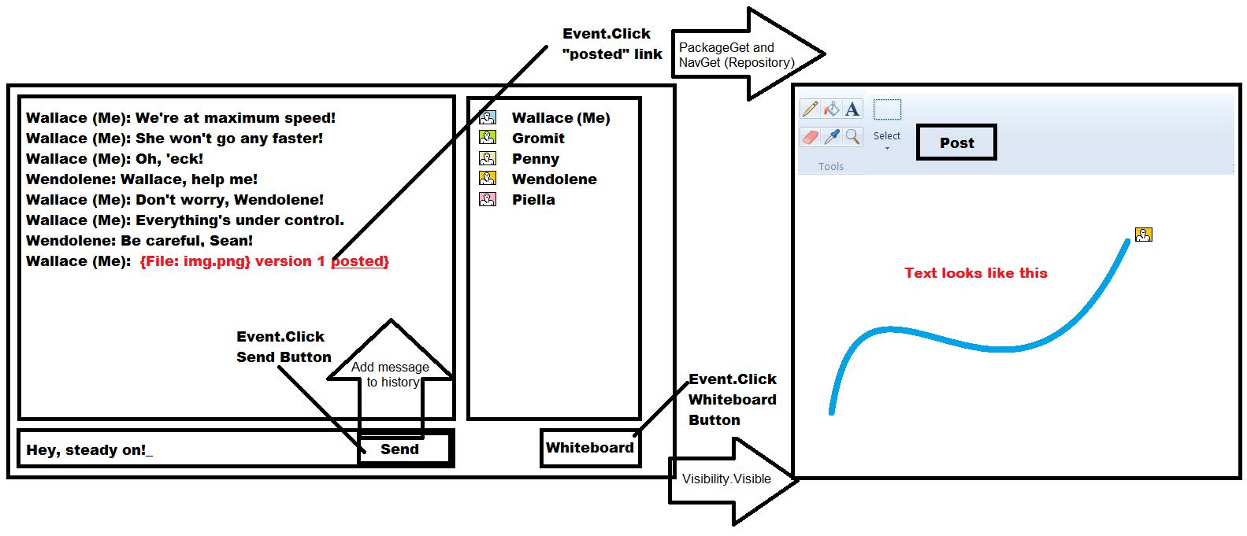
Figure 6: Collaborator Mockup Diagram

Structure
The Collaborator package diagram is shown below in Figure 7. The Collaborator follows a model-view-control pattern. The Chat and Whiteboard functions are implemented via the CollaboratorChat and CollaboratorWhiteboard packages, which use the McastComm communications class.

Figure 7: Collaborator UML Package Diagram

Critical Issues
Security – The MCastComm class uses UDP multicast as an underlying communications infrastructure. Anyone connected to the network hardware can perform a multicast join and listen to the content in the conversation. To secure the content, an optional encryption can be used in the conversation. If encryption is enabled, each users’ client will retrieve an encryption key from the repository server. The multicast messages are then encrypted by the MCastComm package, to prevent unwanted recipients from being able to use the multicasted content.
Flexibility – The Collaborator package must support users coming and going over the course of the conversation. Rather than juggling a list of participants in the conversation, and unicasting content to each user, multicast allows for each user joining in the multicast group. Any time a user wants to post content, the user’s client only needs to post once, via the MCastComm MulticastSender object.
Ease-of-use – The client user will retrieve a single file from the repository server containing a list of conversations. The conversation list contains a multicast address and port number. The multicast address, in default cases, doesn’t need to change. Multiple conversations are allocated via port number. When a conversation is started, the client updates the conversation list so that it contains the conversation address and port number. When the conversation is terminated or timed out, the conversation list is updated to remove the conversation.

Prototype: MCastComm Demo
An example implementation for the multicast communication package, MCastComm was created, to demonstrate the feasibility of using UDP multicast for a collaborative communications backend. The requirements for such a communicator were to support asynchronous joins, and to insulate the Client from having to keep a table of remote users. UDP multicast, though subject to security vulnerabilities, is a good starting point, as evidenced by the prototype.
using System.Net.Sockets;
using System.Net;
using System.Threading;
using System;

namespace multiCastComm
{
public class someEventArgs : EventArgs
{
private string _msg;

public someEventArgs(string msg)
{
_msg = msg;
}

public string msg
{
get
{
return _msg;
}
set
{
_msg = value;
}
}
}

public class McastComm
{
private send s = null;
private recv r = null;

public McastComm(recv _r)
{
Console.WriteLine("Firing up a communicator ");
r = _r;
r.incomingPacketEvent +=
new recv.incomingPacketEventHandler(DisplayContents);

new Thread(r.start).Start();

}

public void broadcastPacket(String packetContent, String port)
{
s = new send("224.5.6.7", port, "10", packetContent);
}

public void DisplayContents(object obj, EventArgs seva)
{
String filename = ((someEventArgs)seva).msg;
Console.WriteLine("{" + filename + "}");
Console.WriteLine();
}
}

public class send
{
public send(string mcastGroup, string port, string ttl, string packetContent)
{
IPAddress ip;
try
{
Console.WriteLine("MCAST Send on Group: {0} Port: {1} TTL: {2}",mcastGroup,port,ttl);
ip=IPAddress.Parse(mcastGroup);

Socket s=new Socket(AddressFamily.InterNetwork,
SocketType.Dgram, ProtocolType.Udp);

s.SetSocketOption(SocketOptionLevel.IP,
SocketOptionName.AddMembership, new MulticastOption(ip));

s.SetSocketOption(SocketOptionLevel.IP,
SocketOptionName.MulticastTimeToLive, int.Parse(ttl));

byte[] b = Encoding.ASCII.GetBytes(packetContent);

IPEndPoint ipep=new IPEndPoint(IPAddress.Parse(mcastGroup),int.Parse(port));

Console.WriteLine("Connecting...");

s.Connect(ipep);

s.Send(b,b.Length,SocketFlags.None);

Console.WriteLine("Closing Connection...");
s.Close();
}
catch(System.Exception e) { Console.Error.WriteLine(e.Message); }
}

public class recv
{
Socket s = null;
public delegate void incomingPacketEventHandler(object sender, EventArgs seva);
public event incomingPacketEventHandler incomingPacketEvent;

private int port;

public recv(string mcastGroup, string port)
{
this.port = int.Parse(port);
s=new Socket(AddressFamily.InterNetwork, SocketType.Dgram, ProtocolType.Udp);

IPEndPoint ipep = new IPEndPoint(IPAddress.Any, this.port);
IPAddress ip = IPAddress.Parse(mcastGroup);
s.SetSocketOption(SocketOptionLevel.IP, SocketOptionName.AddMembership, new MulticastOption(ip, IPAddress.Any));
// Allows multiple sockets listening on a single port, on a given machine
s.SetSocketOption(SocketOptionLevel.Socket, SocketOptionName.ReuseAddress, true);
s.Bind(ipep);
Console.WriteLine("Starting multicast receiver on port {0}", this.port.ToString());
}

public void start()
{

while (true)
{
String message;
byte[] b = new byte[10];
Console.WriteLine("Waiting for data..");
s.Receive(b);
string str = System.Text.Encoding.ASCII.GetString(b, 0, b.Length);
Console.WriteLine("RX: " + str.Trim());
message = str.Trim();
someEventArgs seva
= new someEventArgs(message);
if (incomingPacketEvent != null)
incomingPacketEvent(this, seva);
}
}

public static void Main(string[] args)
{
new recv("224.5.6.7","5000");
}
}
}

The demonstration should verify the ability for two clients, A and B to communicate. One client (A) should post a series of messages, which should show up on both clients’ (A and B) “screens”. Then, after the “conversation” stops, an additional client (C) should arrive and post a series of messages, which are displayed on all three “screens”.
Below is a transcript from the demonstrated “conversation”. User A multicasts a series of 10 messages to all clients. Later, user C arrives within the conversation, and broadcasts to all clients.
Enter the name of the user  A  Starting multicast receiver on port 5000  Firing up a communicator  Waiting for data..  MCAST Send on Group: 224.5.6.7 Port: 5000 TTL: 10  Connecting...  Closing Connection...  RX: A: 0  {A: 0 }  Waiting for data..  MCAST Send on Group: 224.5.6.7 Port: 5000 TTL: 10  Connecting...  RX: A: 1  {A: 1 }  {truncated}  Waiting for data..  Closing Connection...  MCAST Send on Group: 224.5.6.7 Port: 5000 TTL: 10  Connecting...  RX: A: 9  Closing Connection...  {A: 9 }  Waiting for data..  Done  RX: C: 0  {C: 0 }  Waiting for data..  RX: C: 1  {C: 1 }  {truncated}  Waiting for data..  RX: C: 9  {C: 9 }  Waiting for data.. | Enter the name of the user  C  Starting multicast receiver on port 5000  Firing up a communicator  Waiting for data..  MCAST Send on Group: 224.5.6.7 Port: 5000 TTL: 10  Connecting...  Closing Connection...  RX: C: 0  MCAST Send on Group: 224.5.6.7 Port: 5000 TTL: 10  Connecting...  {C: 0 }  Waiting for data..  RX: C: 1  {C: 1 }  Closing Connection...  MCAST Send on Group: 224.5.6.7 Port: 5000 TTL: 10  Connecting...  Closing Connection...  Waiting for data..  RX: C: 2  {C: 2 }  {truncated}  Waiting for data..  Closing Connection...  RX: C: 9  {C: 9 }  Waiting for data..  Done

Five Pillars of Security – Multicast Communication Prototype
While the prototype does demonstrate the ease of handling communications to an ever changing set of multicast participants, it is absolutely necessary to include security protections. According to ISO, a secure system must provide confidentiality, integrity, authentication, access control, and non-repudiation.
- Confidentiality: No untrusted party can access appropriate messages.
- Integrity: Messages cannot be changed during transit without being discovered.
- Authentication: The message needs to be sent by the person/machine who claims to have sent it.
- Access control: Only those users enabled can access the data.
- Non-repudiation: The receiver can prove that the sender actually sent the message.

Requiring any user to retrieve an encryption key from the Repository server satisfies the requirement for authentication and access control. Confidentiality is satisfied with the assumption that the method of encryption is satisfactory for keeping the conversation confidential.
Integrity is not satisfied in this example. In a more satisfactory example, a checksum should be calculated such that tampering with the message would be detected by the receiving client. Additionally, it could be desireable to compute a rolling checksum with each message in the conversation, and broadcast the checksum as part of each subsequent message. Either method is acceptable for assurance of security integrity.
Non repudiation is not truly satisfied in this example. The sender name is provided along with each message. It could be spoofed, however, since the identification is a short human-readable string. To enhance non-repudiation, it would be desirable to encode the MAC address or originating IP address of the sender. A spoofed message from an alternate sender would be detected as it would contain a differing MAC or IP address.

Detailed Architecture: Repository Server
The Repository Server contains a number of server-side plug-in packages, shown below in the package diagram in Figure 8. The top level packages are common to the test and project server architecture, allowing for flexibility and full customization of what features a server will be equipped with. The Comm package provides a common transport method for all outgoing and incoming traffic passed to the server packages.
The Server packages below the top level provide the Repository Server functionality.
Figure 8: Repository Server UML Package Diagram

Repository Server: Comm Package

Concept
The communications package within this architecture supports unicast communications between a given client instance and a given server instance. For messages to get from one client and one server instance, or vice versa, a pair of communicators perform one way communications. Communications cease when a sender, belonging to the client or server issues a terminating message.
The information needed to route a response message is provided as part of the incoming message. The receiving communicator can provide a response back to the source of the original message.

Uses
The Repository Server uses the communication package for the following transactions:
Storing a new source code package to the server
Storing metadata for a source code package
Revising (commanding) metadata for a source code package
Querying for information in the source code packages on the repository files
Querying the encryption key for a secure collaboration conversation.
Starting (commanding) a new collaboration conversation
Terminating (commanding) a collaboration conversation
Commanding a deletion of a source code package

Structure
{Create a package diagram for the Communicator}
Figure 9: Communicator UML Package Diagram
For each plugin, instantiate a communicator on the server.
For each plugin, instantiate a pane on the client.

Critical Issues
Expandability – Because the federated server concept requires multiple servers talking to each other, and to multiple clients, the need for concurrent communications with multiplicity is very critical. Communicators must be able to coexist with potentially thousands of other communicators running concurrently on the same machine, as well as on the same network.
Resource usage – Because of the need for expandibility, it is important to ensure that communications, once complete, return all resources. Additionally, because of the multiplicity of communications, individual instances of the communicator should be lightweight.

Repository Server: RepoQueryServer/Client Packages

Concept
The RepoQueryServer and RepoQueryClient make it possible for the user to retrieve information from the body of source code packages stored within the Repository Server. The RepoQueryServer receives the query, performs the query, packages the query results into an XML message and sends the response to the RepoQueryClient. The RepoQueryClient allows the user to specify the query terms. When the query response arrives, the RepoQueryClient unpacks the reponse and displays the results of the query.

Uses

Users
The user will be the sole user of the RepoQueryClient. The RepoQueryServer will be responsible for handling queries from the user, via the RepoQueryClient, and for handling queries from the test and project servers when they request information pertaining to source code packages.

Uses - RepoQueryClient
The user can specify one or more category filter terms. If a category is specified, only files with associated metadata containing one or more of the categories will be queried using the following usage steps.
The user can specify metadata query terms. For each Metadata Query Term, each metadata file in the aforementioned category or categories will be searched for metadata tags containing the Query Term or Terms. If any are found, the filename, version and tag/value for each Query Term is returned.
The user can specify text strings, or regular expressions to find within content files within the Repository Server. If the aforementioned category or categories are specified, only files with the associated category information will be searched, to server workload associated with this query. Any filename containing the text string or regular expression will be returned, along with its full metadata content.

Uses – RepoQueryServer
The RepoQueryServer handles incoming RepoQueries from the RepoQueryClient as well as from the Test and Project Servers.

Structure
The View of the RepoQueryClient is shown below in the prototype diagram in Figure 10.
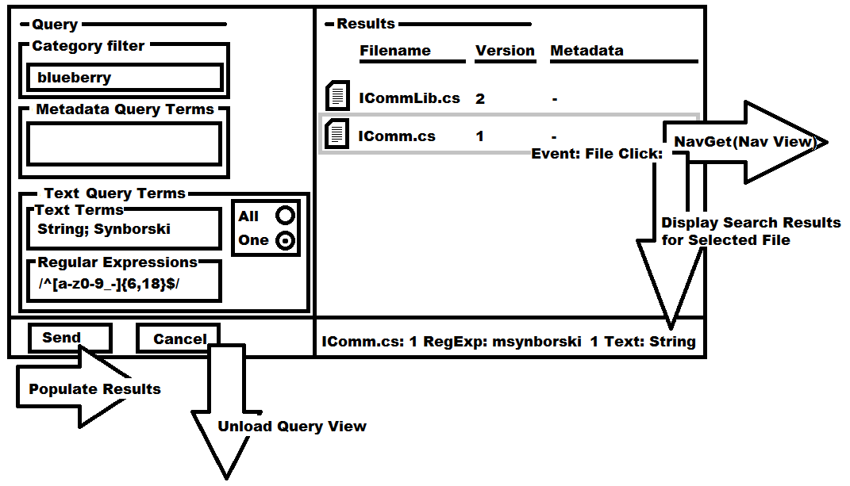
Figure 10: RepoQueryClient View Prototype Diagram
When the user enters this view from the Nav View, the empty Query view appears with no files in the right side (“Results”) pane. The user enters Category, Metadata Query Terms, Text Terms and/or Regular Expressions. If the user presses the Send button, the terms are packaged up into a RepoQuery Service Message and sent via the Communicator package to the RepoQueryServer. The RepoQuery Service Message is handled by the RepoQueryServer, which performs the RepoQuery upon its repository content files.
The RepoQuery package diagram is shown below in Figure 11.
Figure 11: RepoQuery Plugin Package Diagram
RepoQueryClientView.xaml – Contains the WPF-based XAML and code-behind that implements the Query View shown in Figure 10. The implemented class is a Window object.
RepoQueryClient – This package contains the implementation for an AbstractCommunicator, which is used in conjunction with messaging defined in RepoQueryService. RepoQueryService is a shared library used by RepoQueryServer, which provides the construction of the RepoQuery payload in the form of well-formed XML. The communications provided by the RepoQueryClient communicator creates a Sender when the user presses the Send button on the Query View. The Client creates a Receiver for the response, which times out after 5 seconds if a query response has not been received. If a query response is received containing a heartbeat response payload, the 5 seconds is extended.
RepoQueryServer – This package contains the implementation for an AbstractCommunicator, which is uses the RepoQueryService in a similar manner as the client. The Server provides a persistent receiver that waits for incoming queries in the form of a RepoQuery, which is implemented in the RepoQueryService package.
RepoQueryService – This package contains static member functions for populating an XML formatted query given a series of inputs:
- Categories
- Text Search Terms
- Text Search Configuration Terms (find all vs. find one)
- Text Search Regular Expressions
- Metadata Search Terms
The RepoQueryService package also contains static member functions for unpacking data from a RepoQuery response. Namely files, their versions, their associated metadata, their regular expressions contained in the aforementioned file, and their Text Search Terms contained in the aforementioned file.
TextQuery – This package contains a generalized Text and Metadata search facility. The aim in generalizing this package is to provide the ability to search a given file system for content and associated metadata to support a diverse field of applications containing and reaching beyond the Repository, Test and Project Servers. For a given file, the TextQuery will provide the following facilities in numerical order of execution:
- Look for an associated metadata file. If one is not located, cease processing and return an indication that the Query did not find a metadata file for the file.
- Look for one or more categories in the metadata file content. If a <categories> tag is found within the file, the provided category or categories in the TextQuery must be found. If one is not located, cease processing and return an indication that the category was not found.
- Look for metadata tags specified by the TextQuery. If any of the tags are present in the metadata file, return the contents. If none are found, return an indication that no metadata content was found. This is not the same as step 1, above.
- Look for text terms specified by the TextQuery. Additional configurations for this facility are also specified in the TextQuery, such as the requirement to find all text strings or one. Return the number of appearances of each text string, along with the position in the file of each occurrence.
- Look for regular expressions specified by the TextQuery. Return the strings found by the regular expression, along with the position in the file of each occurrence.
MetadataLib – This package contains low level functionality that is used by TextQuery, for returning information from Metadata files. The metadata file format is well-formed, flat XML and contains element-only tags for the following:
- Metadata – Root node.
- Type – Can be one of many types of metadata: SourceCode, Authentication, Test, Project, Statistics and so on. When new types of metadata are created, the MetadataLib package must be recompiled and distributed. RepoQuery Metadata is of the type – SourceCode.
- ResponsibleIndividual – Who is the owner user associated with the Package filename. Can be only one Package RI.
- Version – Which version is the metadata. This is written by the Repository Server by the PackageCheckinServer.
- Categories – What categories does the source code package belong to?
- Dependency – Filenames and versions that the given source code package depends on directly.
- Description – Text description of the source code package, written by the Responsible Individual at time of check-in.
- Filename – The filename of the source code package.

Critical Issues
Access Control – The Repository Client and Server provide the facility to access source code files and content that may not be appropriate for every user. Limiting access to files using authentication, user groups and the metadata content will allow only the users that are logged in to the server and have membership in a particular user group to successfully perform a RepoQuery and qualify for a response from the RepoQueryServer.
Search Latency – As the Repository Server fills up with content files, potentially being very large text or source code packages, potentially running text and searches with multiple terms, the processing times for queries can get very high.
According to current human factors practices in server-client systems, the user should never have to wait very long for a visual response, even if processing is incomplete. It is desirable to present the user with a liveliness indicator while text queries are being performed. A 16-petal liveliness indicator will rotate 22.5 degrees clockwise every 500 milliseconds while the search is executing. An example liveliness indicator is shown below in Figure 12.
If the RepoQueryClient does not receive a response for 5 seconds, the liveliness indicator will stop spinning. If the RepoQueryClient does not receive a response for another 5 seconds thereafter, the receiver will fail, and an error window will appear indicating that the Server has unresponsive.

Figure 12: RepoQueryClient Liveliness Indicator

Repository Server: PackageDeleteServer/Client Packages

Concept
The PackageDeleteServer Package allows for the User, if he/she is an authenticated user, belonging to the administrator group, to delete source code packages and metadata files from the Repository Server. The PackageDeleteServer provides the file system functionality, as well as the server-side messaging to remove packages. The PackageDeleteClient provides the view and client-side messaging to do the same.
Source code packages reside on the Repository Server file system. No file is ever permanently deleted from the file system at runtime. The file is removed to a holding folder outside the repository, should the file need to be recovered at a later date. This is possible outside the functionality of the Repository Server, and deletions should be done with discretion by the administrator.

Uses

Users
The user will be the sole user of the PackageDelete package. The PackageDelete functionality will not have implemented accessibility within the Test Server or Project Server.

Uses – PackageDeleteClient
The user can select a file on the Nav View. If the user is authenticated and belongs to the administrator group, a Delete button appears. If the user presses the delete button, and the user is sure they want to delete the file (via a confirmation dialogue), all parent/child relationships are updated within the metadata to remove links. The file and its metadata is moved to the deleted folder.
An example of the PackageDeleteClient’s effect on the Nav View of the Repository Client is shown below in the prototype diagram in Figure 13.
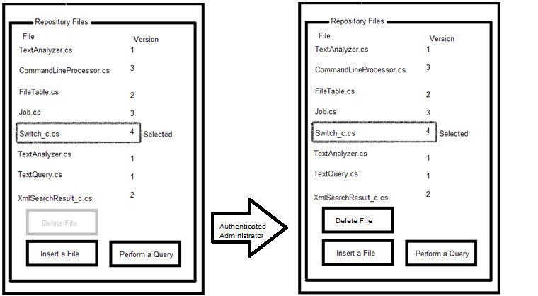
Figure 13: PackageDeleteClient in Nav View

Uses – PackageDeleteServer
The PackageDeleteServer handles incoming PackageDelete commands from the PackageDeleteClient .

Activities: PackageDelete
When a PackageDelete Command message arrives at the PackageDeleteServer, the authentication of the current logged in user is checked against the list of users in the administrator group. If the user is not an administrator, the response to the PackageDeleteClient indicates a failure.
If the current user is authenticated as an administrator, the parent and child dependencies of the given file are “unhooked”, meaning they are updated to indicate a missing dependency. The list of responsible individuals involved in an “unhook” is aggregated, and included in the PackageDelete response for display to the administrator user. The file is then moved to the delete folder.

Structure
The structure of the PackageDelete package is shown below in the UML package diagram in Figure 14. The top level packages, PackageDeleteClient and PackageDeleteServer compose the pair of PackageDelete plugin files.
Figure 14: PackageDelete UML Package Diagram

Critical Issues
Race conditions, access problems – Files that are in use while the administrator user commands a deletion must be gracefully removed. Otherwise, for example, one client will see a result come back for a file that was deleted between the time the file came up in a RepoQuery and the time the file was unlinked and moved to the deleted folder by a separate admin-authenticated user.
In the event that a file is in use, and the file deletion attempt occurs, the file will be removed, but a warning will be issued to the administrator containing a list of potentially affected responsible individuals. The list will be assembled using the parent/child relationships of the affected file and the RIs in the associated metadata thereof. Given the potential inconvenience of a missing file, file deletions must be used with great care.

Repository Server: NavGetServer/Client Packages

Concept
The NavGetServer and NavGetClient packages provide the main navigation view of the Repository Server. The Nav View is implemented within the NavGetClient plugin. The user is presented with this view upon successful authentication within the Repository Server. The NavGetServer and NavGetClient present the user with server/client communications information (whether the client is connected to the server). Repository contents that are accessible to the authenticated user, given their level of permissions, are displayed to the user. Contents can be filtered by category. File contents and associated metadata are shown for the Current File. Metadata can be modified, depending on the level of authentication of the current user. Any changes to metadata are communicated to any additional users viewing a given file.

Uses

Users
The user will be the sole user of the NavGetClient. The NavGetServer will be responsible for handling queries from the user, via the NavGetClient, and for handling navigation queries from the test and project servers when they request information pertaining to Repository Content information.

Uses - NavGetClient
Upon initial connection, the NavGetClient performs a NavGet Query to the NavGetServer. The results of the NavGetQuery are displayed within the leftmost pane, entitled “Navigation”, under the Categories and Files listbox.
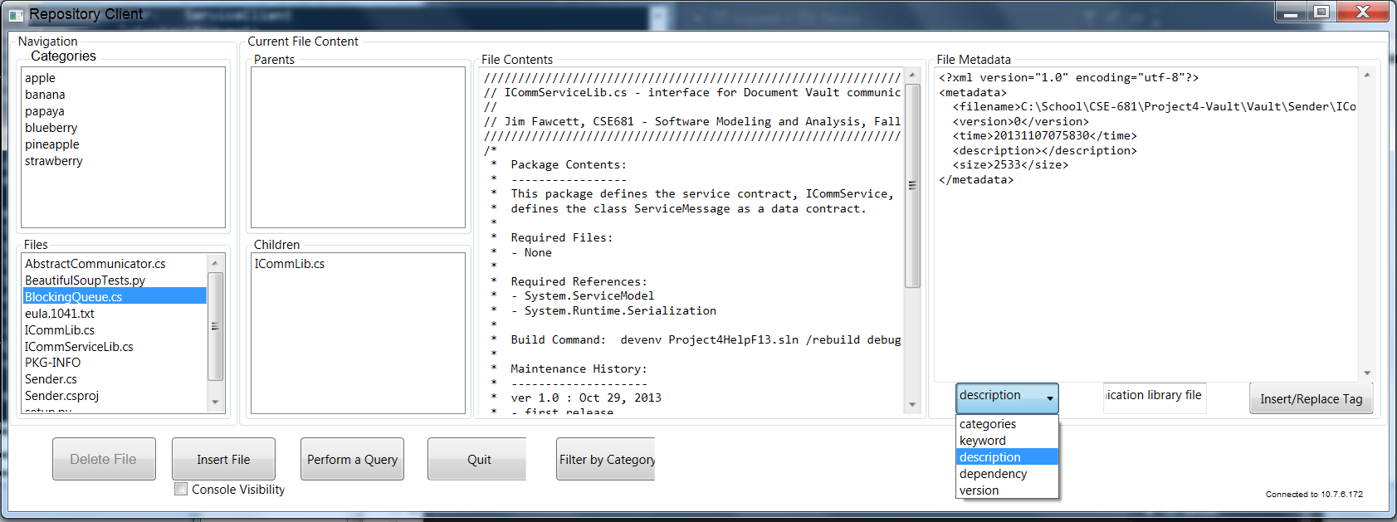
Figure 15: Nav View (NavGetClient)

Uses – NavGetServer
The NavGetServer handles incoming NavGet queries from the NavGetClient. The NavGetClient may exist within the Repository Client, or any other Server in the server federation.

Structure

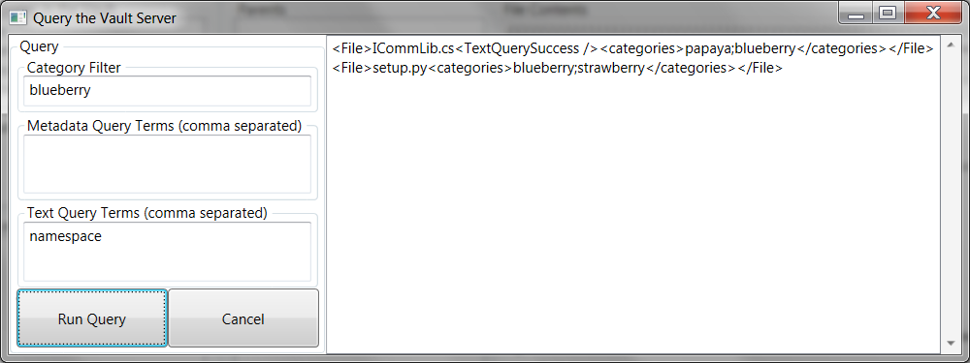

Critical Issues

Repository Server: PackageGetServer/Client Packages

Concept
The RepoQueryServer and RepoQueryClient make it possible for the user to retrieve information from the body of source code packages stored within the Repository Server. The RepoQueryServer receives the query, performs the query, packages the query results into an XML message and sends the response to the RepoQueryClient. The RepoQueryClient allows the user to specify the query terms. When the query response arrives, the RepoQueryClient unpacks the reponse and displays the results of the query.

Uses
Users
The user will be the sole user of the RepoQueryClient. The RepoQueryServer will be responsible for handling queries from the user, via the RepoQueryClient, and for handling queries from the test and project servers when they request information pertaining to source code packages.
Uses - RepoQueryClient
The user can specify one or more category filter terms. If a category is specified, only files with associated metadata containing one or more of the categories will be queried.
The user can specify

Structure

Critical Issues

Repository Server: PackageCheckinServer/Client Packages

Concept
The RepoQueryServer and RepoQueryClient make it possible for the user to retrieve information from the body of source code packages stored within the Repository Server. The RepoQueryServer receives the query, performs the query, packages the query results into an XML message and sends the response to the RepoQueryClient. The RepoQueryClient allows the user to specify the query terms. When the query response arrives, the RepoQueryClient unpacks the reponse and displays the results of the query.

Uses
Users
The user will be the sole user of the RepoQueryClient. The RepoQueryServer will be responsible for handling queries from the user, via the RepoQueryClient, and for handling queries from the test and project servers when they request information pertaining to source code packages.
Uses - RepoQueryClient
The user can specify one or more category filter terms. If a category is specified, only files with associated metadata containing one or more of the categories will be queried.
The user can specify
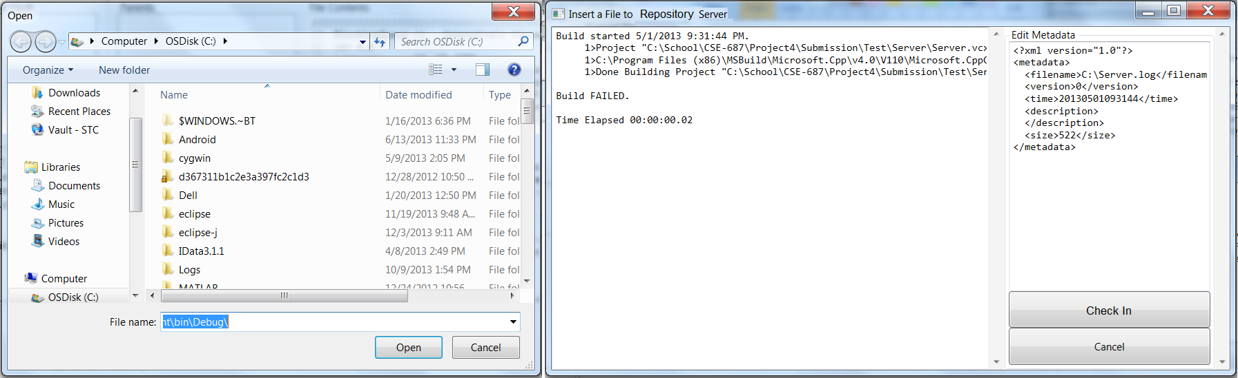
Figure 16: PackageCheckinClient Prototype Diagram

Structure

Critical Issues

Repository Server: MetadataUpdateServer/Client Packages

Concept
The RepoQueryServer and RepoQueryClient make it possible for the user to retrieve information from the body of source code packages stored within the Repository Server. The RepoQueryServer receives the query, performs the query, packages the query results into an XML message and sends the response to the RepoQueryClient. The RepoQueryClient allows the user to specify the query terms. When the query response arrives, the RepoQueryClient unpacks the reponse and displays the results of the query.

Uses
Users
The user will be the sole user of the RepoQueryClient. The RepoQueryServer will be responsible for handling queries from the user, via the RepoQueryClient, and for handling queries from the test and project servers when they request information pertaining to source code packages.
Uses - RepoQueryClient
The user can specify one or more category filter terms. If a category is specified, only files with associated metadata containing one or more of the categories will be queried.
The user can specify

Structure

Critical Issues

Users

Content Providers
Content Providers are any user that is concerned with adding, maintaining, organizing and verifying content. Some examples of Content Providers are software engineers, testers, QA representatives, technical writers, reviewers, bloggers, reporters and authors. In terms of the Vault Client and Vault Server, Content Providers wish to have control over individual files, and will likely be the “fine grained” editors for metadata associated with the text files. Content Providers will be the most frequent users of the Vault Client and Vault Server, therefore the interface should be suited to them. At the highest level, these users will perform the following basic actions:

Add Files
Users will use the Vault Client to add content to the Vault Server. Specifically, the user will select a content file to be inserted into the Vault Server, and then metadata associated with the content file will be edited local to the Vault Client. Once the user is satisfied with the state of the metadata, they will insert the content file and the metadata file.

Modify Metadata
The User can make changes to metadata at any time without having to insert a new or revised content file. This aspect of design allows users to add additional metadata to an already existing content file. This ability to describe the content file is important in iterative development. For example, a content file may be used by additional projects or modules. A user may wish to add additional category to describe the new use so that the full impact can be considered the next time someone wants to make a change to the file.

Queries
Users will need to perform queries within the content files, and their associated metadata files. The users will use the Vault Client to enter the query inputs, to initiate the query once they are satisfied with the query inputs, and will want to view the results of the query in a simple manner that is integrated within the part of the software where the inputs are provided. It is common for a user to learn that they need to make small changes to their query inputs based on the results of a previous query. The Vault Client will allow for this type of iterative query usage.

Navigate Relationships
Users will want to view relationships between content files. Parent relationships (a given file is used by other files, said to be “parents”) and child relationships (a given file uses other files, said to be “children”) will be viewed using the Vault Client. The user can click on a given parent or child file to view the content and its associated metadata. Given a set of usage relationships in the files in the Vault Server, the user can navigate throughout the dependencies using the Vault Client.

Customers
Customers wish to oversee progress as content is being developed. The query function supported by Vault Client and Vault Server could be used by customers to provide a report composed of the metadata. They may wish to see what changes have occurred in files with a given category, or to check for resolution of a problem associated with a given keyword. The content providers may wish to perform development in a way that is isolated from customers, so it is desirable to restrict Vault Client from accessing all of the contents within the Vault Server if the current user is a Customer. Additionally, Customer users should not be allowed to insert files.

Program Managers
The program manager or project manager will not directly use the Vault Client or Vault Server. In a well working team, his or her software, test and QA staff will be directly in contact with content, and report issues and status to the PM so they can spend their time tending to higher level programmatic issues and oversight.

Administrators
Administrators are a special type of users. These will not be Content Providers, however, they should have the full set of capabilities in their usage policy as that of Content Providers. Administrators are users that should not add or change content unless in support of Content Providers. For example, if a Content Provider accidentally inserts the wrong file and adds metadata associated with it, the Administrator would be able to reverse these actions.

Activities

User Activities (inputs)
The user is capable of a number of actions with the Vault Client and Vault Server. The following list of activities associated with the user’s inputs into the Vault Server and Vault Client are a condensed form of the project 4 requirements.
- The user can query the repository
- The user can view a content file and its metadata
- The user can view dependencies upon and of a content file
- The user can annotate a content file
- The user can insert a content file and its metadata
- The user can filter the list of files in the navigation view by category
The two view user activities both utilize the same verb, and are implemented on the same Vault Client view. More on this can be found in the Organizing Principles section of this document.
A note about user interaction events and communication events:
It is important for the reader of this document to note that events that involve the user interacting with the Vault Client are shown in activity nodes in the following sections, starting with “User …”, for example “User clicks ‘Insert File’ button”. Flows that span swim lanes correspond to messages in Figure 6, in the Communications section of this document.

Query
When the user chooses to query the repository, the Vault Client packages up the inputs to the query into a Query Request. The Query Request includes an additional keyword if the user is a Customer. The Query Request is sent to the Vault Server. The Vault Server validates the Query Request, and performs the Query using TextAnalyzer. The results of the Query are sent back to the Vault Client for display. If the Query Request is invalid, the Vault Server sends an Error back to the Vault Client. The Vault Client handles the Error (not shown). The Vault Client receives the Query Results, and updates the Results portion of the Query View.
The Query activity is shown below in the Activity Diagram in Figure 1.

Figure 17: Query Activity Diagram

View
When the user chooses to view a file from the repository, they must specify the filename they wish to view. This will be done by clicking a filename in the navigation view, or by performing an action that causes the view of a file to be updated to a different file reference. Either of these inputs will take in the filename, the user type and the version of the file to be viewed. These elements are used to build a View Request, which is sent to the Vault Server. The Vault Server performs a validation of the content of the message, checking if the filename exists, and is accessible by the specified user type. If this validation fails, an error is sent back to the Vault Client. Otherwise, the file content is accessed, and used to populate a View Response.
The lists of children and parents are generated for the specified file, and this pair of lists is inserted into the View Response. The View Response is sent to the Vault Client for updating the Navigate View.
The view activity is shown below in the Activity Diagram in Figure 2.

F

Figure 18: View Activity Diagram

Annotate
When the user chooses to annotate a file, he or she will add metadata to the file using the Insert View of the prior to it being sent to the Vault. The annotation activity is performed using the Insert View of the Vault Client. Initially, a file must be selected by the user from the local file system of the Vault Client. At this point, the content text and metadata is displayed in the Insert View. The metadata items that can be determined with regards to the file are added via the appropriate tags in the metadata:
- Filename
- Data/time
- File size
The user will enter the following additional metadata:
- Description
- Dependencies
- Keywords
- Categories.
The metadata will be updated with each addition of a tag/value pair. The activity is complete once the user chooses to insert or cancel the annotation.
The annotate activity is shown below in Figure 3

Figure 19: Annotation Activity Diagram

Insert
When the user chooses to insert via the Insert View of the Vault Client, the content file and its metadata (see Annotate) are used to build an Insert Request, which is sent to the Vault Server. The Vault Server validates the Insert Request successfully if the user is not a Customer, as they are not permitted to insert files into the Vault Server. Upon successful validation, the Vault Server stores the content file and metadata files on the Vault Server file system. The Vault Server sends a View Response back to the Vault Client to update the current file in the Navigation View.
The insert activity is shown below in the Activity Diagram in Figure 4. Design details pertaining to file transfers involved with the “Insert Request” message can be found in the Composition Section, in the VaultComm package.

Figure 20: Insert Activity Diagram

Filter
When the user chooses a category filter in the Navigation View, the files in the Navigation View will be filtered by the category tag, and the selected category value that he or she clicked on in the Categories portion. The user has the choice to set or unset the category filter using this portion of the Navigation view.
When the user sets or unsets a filter, a Filter Request will be created by the Vault Client and sent to the Vault Server. The Vault Server will perform a TextAnalyzer query for the category specified, and create a list of Files and associated information to package into a Navigation Response. The Navigation Response is received by the Vault Client, which is displayed in the Navigation View.
During the initial connection of Vault Client to the Vault Server, the Vault Client will send a Navigation Request with no filter set in order to be able to display the files in the Navigation View. This behavior is shown below in the state machine diagram in Figure 5.
Figure 21: Filter State Machine Diagram

Delete
If a user is an Administrator user, the option to delete a selected file in the Navigation View will be carried out by the Vault Server. The Vault Client will send a Delete Request message to the Vault Server. The Vault Server will delete the latest version of the file on its file system. If the file is not found, or the user is not an Administrator, an error will be sent to the Vault Client, otherwise a Navigation Response will be sent so that the Vault Client can show the new state of the repository after the delete.

Communications
The Vault Client and Vault Server work in conjunction to allow the user to query, view, filter, annotate, delete and insert content files. The following communication diagram shown in Figure 6 illustrates at a high level the two software items with all possible communications between them. The user is positioned coincident with the Vault Client because he or she interacts with the Vault Server indirectly through the Vault Client. A login message is required for supporting the design goals for Securing content from external Vault Client users, however it is not shown in the diagram because it is sent only once to the Vault Server upon initial connection. Login credentials are not required in the requirements specification for Vault Client/Vault Server.
Figure 22: Vault Client and Vault Server Communication Diagram
A single WCF-based communications package will be shared by Vault Server and Vault Client. Specific communication design considerations are discussed in the VaultComm package section of the Composition portion of this document.

Composition
The Vault Client and Vault Server will be designed for the reuse of code packages, within the two different pieces of software, as well as for future iterations thereof. The composition of the Vault Client and Vault Server are shown below in the package diagram in Figure 7.
The application packages will be individually capable of invoking the Vault Client Driver or Vault Server Driver packages via the public interface of their respective class instances. This architecture allows for future retargeting of the Vault Client Driver or Vault Server driver to a variety of applications.
Figure 23: Vault Client and Vault Server Package Diagram

Partitions
The following individual packages are components of the Vault Client and Vault Server.

Vault Client Driver
The Vault Client Driver contains a public interface that is accessible to the VaultClientGui, and provides this interface for future retargeting for network or command line (VaultClientCmd) variants of the Vault Client. The driver will be controlled by the VaultClientGui, which will provide a wrapper for the Vault Client driver’s public interface.

Vault Server Driver
The Vault Server Driver, similar to the Vault Client Driver, contains a public interface that is accessible to application specific wrapper. In the case of the Vault Server, the Vault Server Driver will be controlled by the Vault Server Cmd, which will provide a wrapper for the Vault Server driver’s public interface.

TextAnalyzer
The TextAnalyzer package, which is documented in the project 1 OCD, provides functionality for querying content files and their associated metadata. This package contains a job class that is designed for reuse, similar to the driver packages described above. The TextAnalyzer is capable of a parameterized search of content and metadata files, with or without recursion. Text search terms can be queried within the file system, requiring either all of- or one of- the text terms for a file to be included in the results. Metadata search terms, in the form of tags, will return a list of values for the specified tags. If the text search and metadata search terms are specified, a “hybrid” search will be performed, only returning metadata values for files containing the specified text terms.

MetadataGen
The MetadataGen package, which is documented in the project 1 OCD, provides functionality for creating metadata files for a set of inputs. This package contains the reused job class used in TextAnalyzer. MetadataGen creates a well-formed .XML file, with a set of tags that are designed for use with the TextAnalyzer package. The annotate activity in the Activities section of this document summarizes most of the tags that are supported by MetadataGen.

VaultComm
The VaultComm package is used by both the Vault Server and Vault Client. This package uses a FileServer and FileReceiver client, which are Windows Communications Foundation (WCF)-based components. These components implement a ServiceContract that contains messages for the transfer of content and metadata files, lists of dependencies for use in the Navigation View and the full set of messages in the Communications subsection of this document. This architecture allows for reuse of sending and receiving of messages between the Vault Client and Vault Server. File transfers will be sent in partitions, to allow for large content files to be transferred. This design constraint requires the use of per-session instancing, since file handles need to be left open across successive calls to the transfer service. The implementation of the channel binding will use WSHttpBinding so that messages arrive in order, since per-session instancing is used for file transfers.

QueryResult, FileNavList and FileContent
QueryResult, FileNavList and FileContent are packages for use with Vault Client and Vault Server communications.
The QueryResult class will be populated with the result of TextAnalyzer queries. The QueryResult class ToString() function will allow for readable output such that a command line executive of Vault Client can be developed at a later time. The QueryResult class will contain a list of filenames, their version numbers, and metadata tag/value pairs that were located within the files in the filename list. The Query Request message, when handled by the Vault Server will result in a Query Response, which contains a QueryResult object.
The FileNavList class will be populated with the set of files, filtered by the Category filter (summarized in the Activities section of this document) in the Vault Server. The FileNavList class ToString() function will allow for readable output such that a command line executive of Vault Client can be developed at a later time. The FileNavList class will contain the following private member data:
List<File> navigationFiles;
The Filter Request message, when handled by the Vault Server will result in a Navigation Response message, which contains a FileNavList object.
The FileContent class will be populated with a single Content file’s text content and metadata, as well as a list of parent filenames and versions and a list of child filenames and versions. The FileContent class ToString() function will allow for readable output such that a command line executive of Vault Client can be developed at a later time. The FileContent class will contain the following private member data:
String contentText;
XDocument metadata;
List<File> children;
List<File> parent;
The Insert Request and View Request messages, when handled by the Vault Server will both result in a View Response message, which contains a FileContent object.

Organizing Principles

Views
The Vault Client and Value Server activities are shown below in a mockup diagram of the Vault Client views. The proposed design features three stateful views: the Insert View, the Navigate View and the Query View. Initially, the Vault Client (GUI) connects to the Vault Server and displays the Navigate View. The Insert and Query Views are shown conditionally “above” the Navigate View so that changes driven in either of these two views can be shown occurring “in the background” on the Navigate View, resulting from the user’s actions.
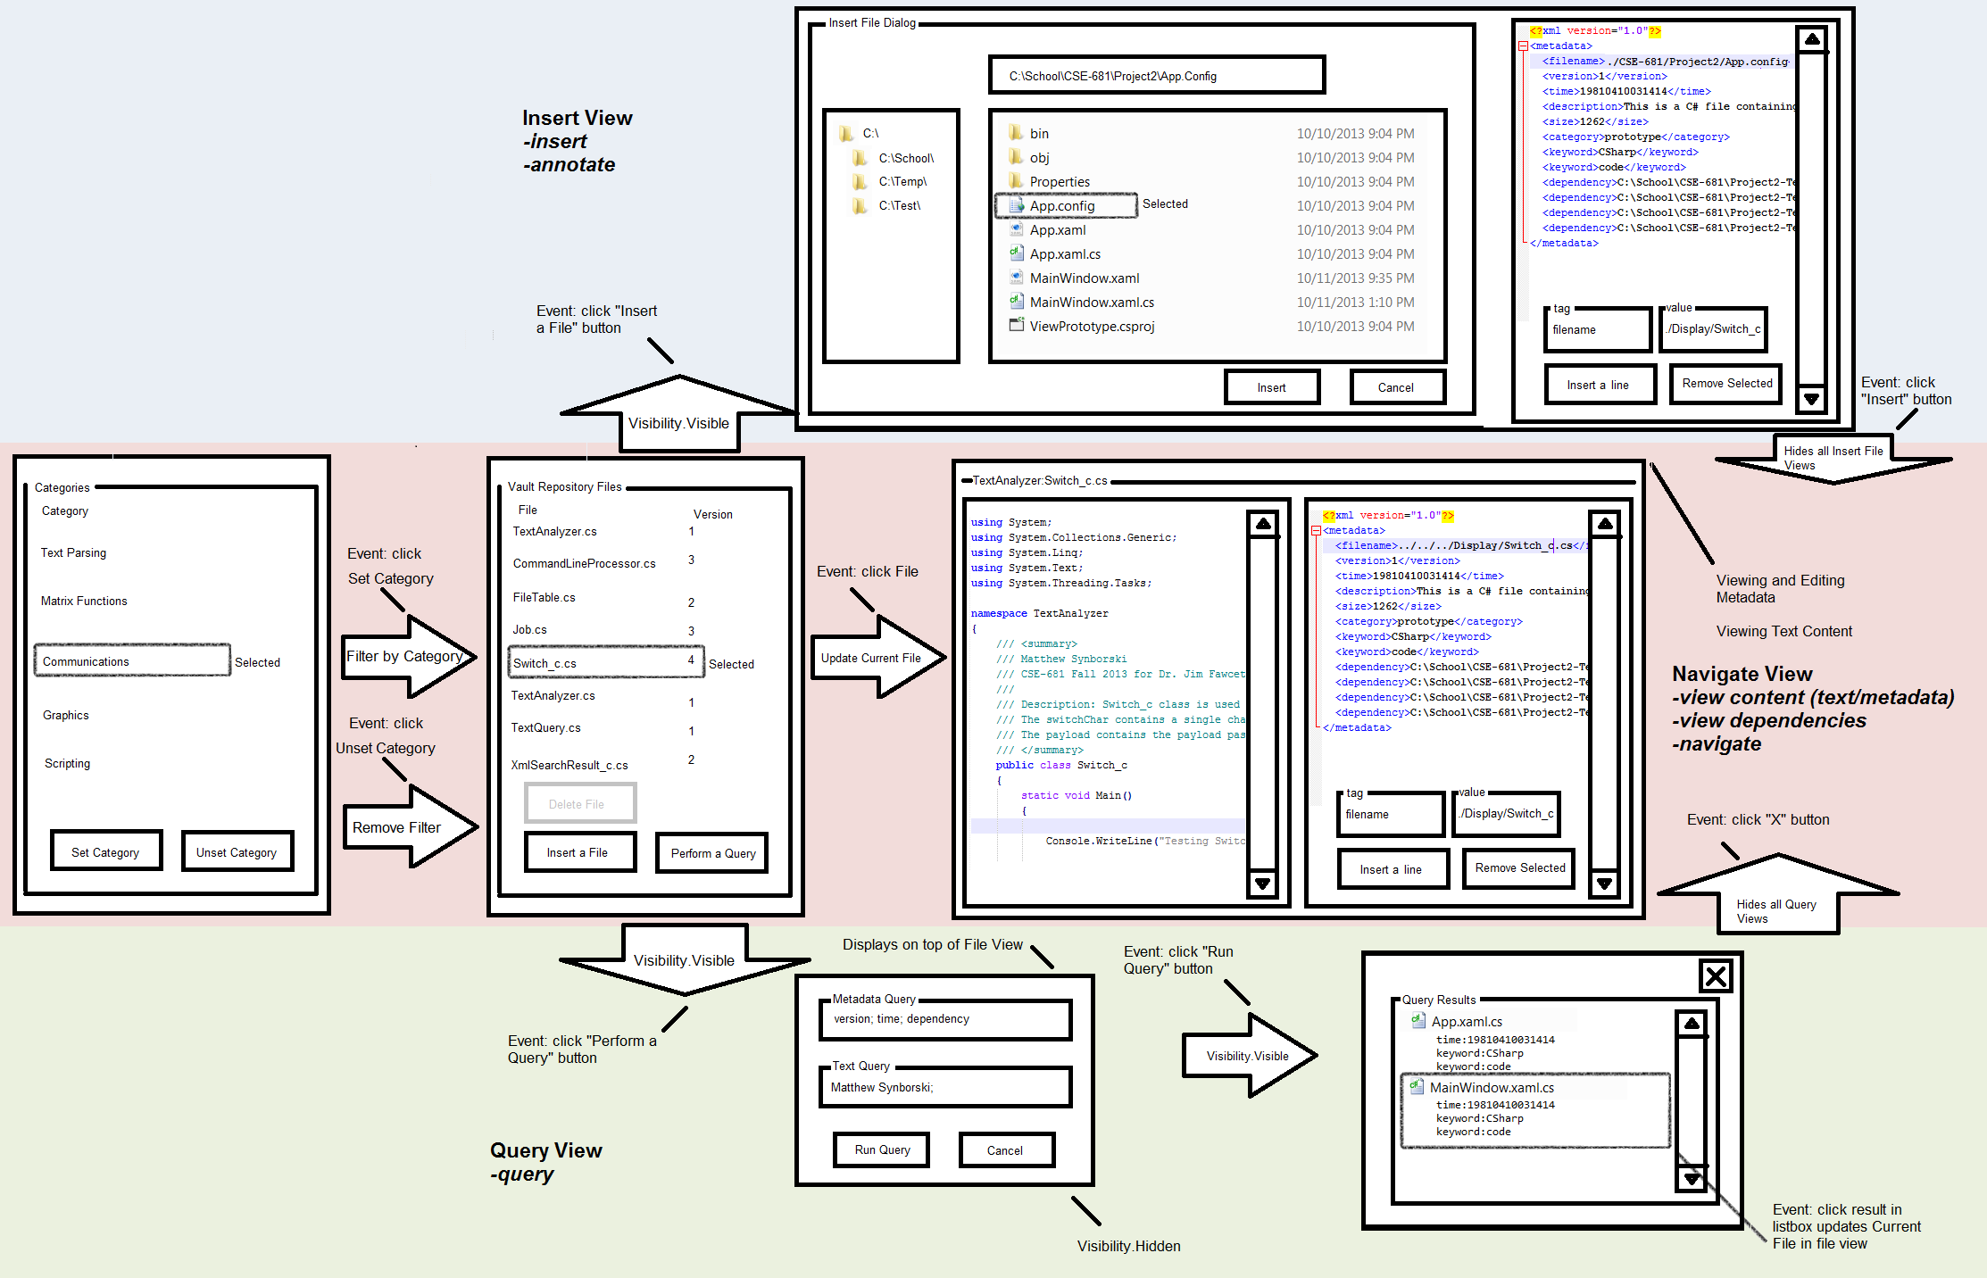
Figure 24: Mockup Diagram of Vault Client (GUI)

Critical Issues

Feasibility
The Vault Client and Vault Server must be developed within a three-week period. The architecture chosen reuses low level modules for query and metadata creation. Additionally, proven technologies are employed for communication and for the graphical user interface. These design choices will allow the development to be accomplished within the timeframe. Development will be performed on time within the budget of $0.

Security
The Vault Client and Vault Server may contain content that should be exclusive from certain users. For example, a company may have customers that should not access each other’s content. Another example is a customer that should not be able to access files that are not released. The Vault Client and Vault Server will employ login policies, allowing for multiple levels of access:
- Customer – Can only perform searches on content that is released. When a “Customer” user uses Vault Client and Vault Server, all of their searches are automatically prepended with a “Customer” keyword metadata search. This prevents all content files without the “Customer” keyword to be stripped from search results. The files in the navigation view will only show up in the file navigation if they are so marked as released files.
- Employee – All employee users can view content files without restriction. Employee users cannot delete content files.
- Administrator – Can perform all functions. Administrators have the ability to delete content files. Only one administrator may be logged into the Vault Server at a time.
The proposed solution to this problem is to include the user type in the View Request, Insert Request and Navigation Request messages. The Vault Server will handle these requests, verifying that the user type is permitted to perform these actions. In the event that a customer is attempting to perform these actions, the responses will be denied or filtered appropriately. Additionally, the underlying messaging to delete a file will be denied (via an error) if the user is not an Administrator.

Code Maintainability – Repository State
The Vault Server may be restarted multiple times over its lifetime. There exists a tradeoff between implementation reuse and code complexity. That is, if the file system is used as the state of the repository, the code complexity will be high, in the event that changes are made in the future. On the other hand, if the implementation of Vault Server includes a class with a compact interface with functions for getting the list of files in the repository, deleting files, getting dependencies and so forth, future additions of design will be easier on other developers.

Simultaneous File Insertion
Multiple Vault Client instances may wish to connect to the Vault Server. This suggests that the Vault Server must support all of the requirements in the specification in a simultaneous concurrent manner. If multiple clients attempt to submit a file, the Vault Client must support this. To handle this requirement, the Vault Server will employ a single message queue. Files will be written to a temporary filename suffixed with a GUID. When the file transfer is completed and the file is closed, the files will be inserted into the Server with subsequent version numbers.

Conclusion
The Vault Client and Vault Server will provide the required functionality specified in the project 4 requirements, while delivering excellent usability, reliability and code reusability. The WPF-based graphical user interface will provide all of the basic functionality in a single window. The shared WCF-based communications design will provide a maintainable architecture, which can be expanded for both software packages with minimal labor. Additionally, both Vault Server and Vault Client are designed for portability such that application specific code can be easily developed to retarget these packages for command line Vault Client usage, or perhaps a WPF-based Vault Server application for local server maintenance.

